**TRIBHUVAN UNIVERSITY**

LUMBINI ICT CAMPUS

Gaindakot-4, Nawalpur



**Lab report on:**

**Software Project Management**

**Submitted by**: **Submitted to:**

Name: Bipin Paudel Tulsi Sapkota

Faculty: BCA Semester: VII

# **Introduction of Jira**

Jira is a software tool that helps teams to manage and organize their work. It's particularly popular for software development projects but can be used for various types of tasks. With Jira, teams can create and track tasks, prioritize work, and collaborate on projects. It provides a centralized platform for planning, tracking, and releasing projects, making it easier for teams to stay organized and work efficiently.

**Overview of Jira.**

* Go to the Jira website (https://www.atlassian.com/software/jira) and create an account. Then the following screen will appear

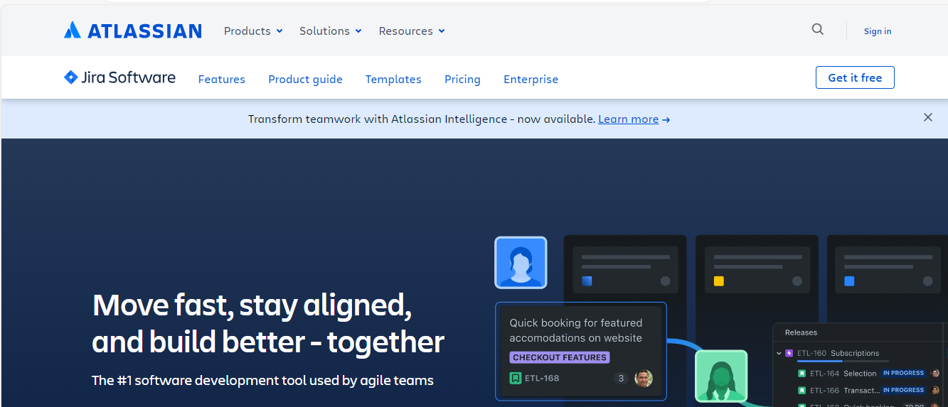

* Once you are logged in, click the "Create a Board" button to create a new board. You can choose a template or create a custom board.

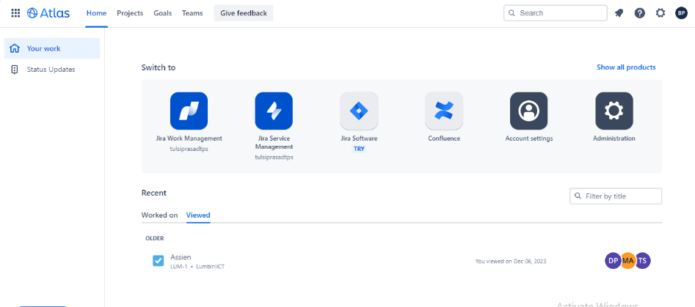

**Method of Creating a Project**

* After Login in Jira website there is Click of Jira Software (try) button ,then click on try it now
* After Click that new page is opened to add jira software to the site. Enter the input field according to your project.

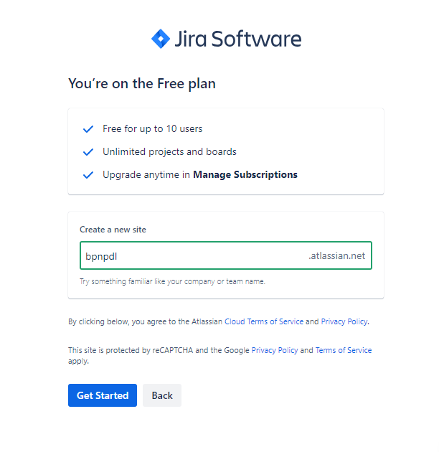

* Then click on Get Started Button, working process begins…After finishing the working process click on go to jira Software button.

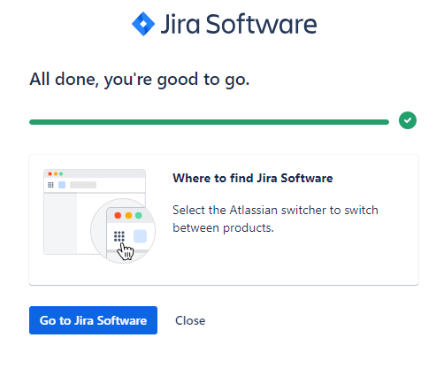

* After that your own atlassian link is created <https://bpnpdl.atlassian.net/welcome/software> and page is shown to select the project management template. Here I am choosing popular jira templete called Kanban which is a flexible and efficient way to manage agile work, with a board and timeline.

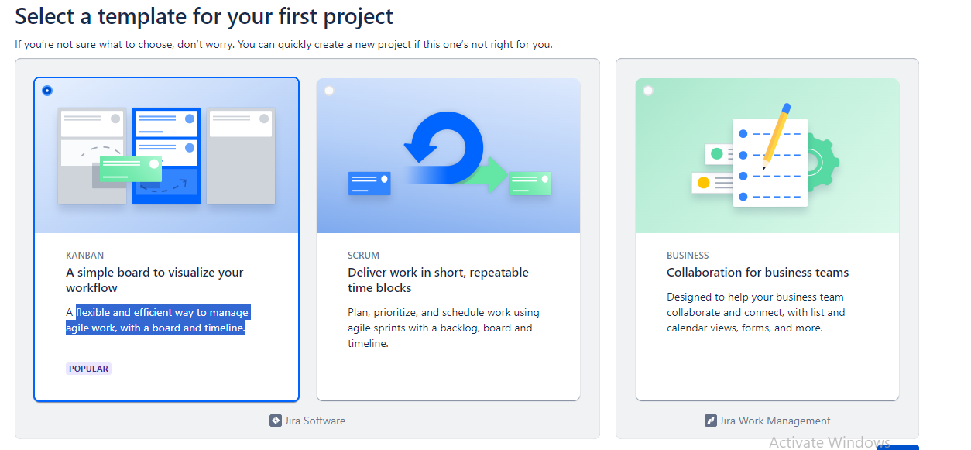

* Then there is page which again says to enter the project name. I am writing project name bpnpdl portfolio.then click on create project button.
* This is the Jira project management dashboard. From here we can manage tasks to team members.

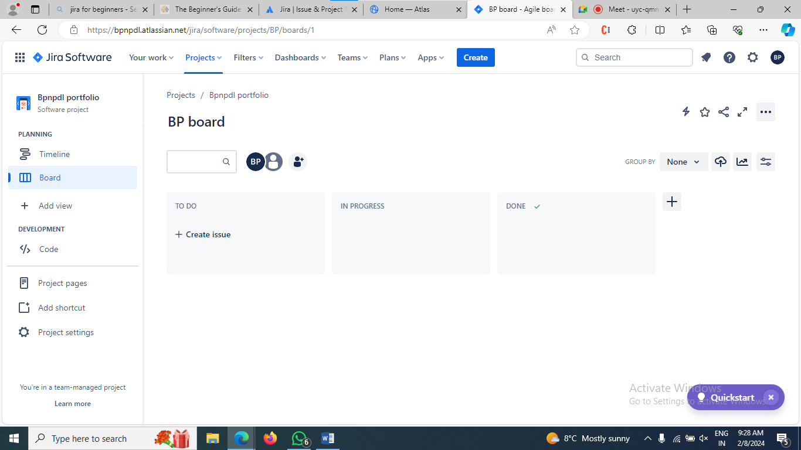

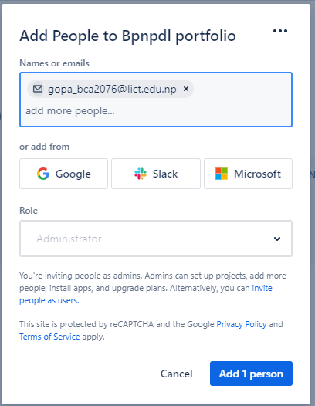

**Method of Adding New Team Members**

* There is add people icon in dashboard click on it

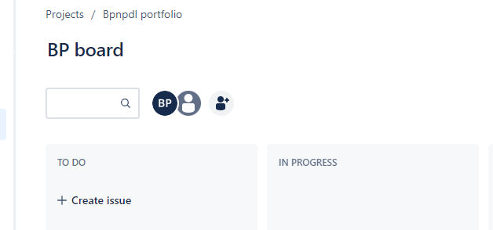

**Manging the Tasks:**

As Default there is three columns todo,in process and done to manage tasks and issues.

* On todo list click on Create issue, then write the task and press enter button .Assign the task to the respective person.

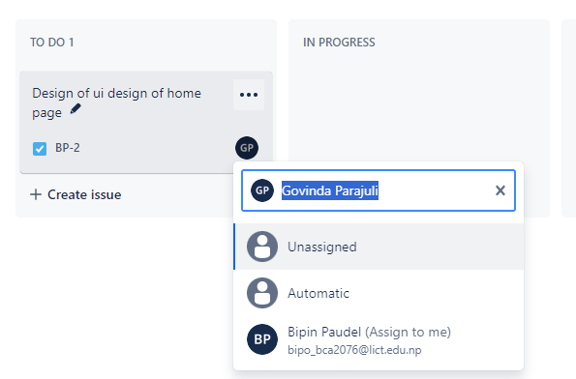

* Then add some other tasks. If the task is in progress or in competed simply drag the task to the respective colums.

